General Biology Year 11 2021


Unit 1 - Classification and cell processes
Task 4: Extended Response – Photosynthesis
(weighting 10%)
MARKING KEY

Name: | Teacher: | Date: | Score:  /14

Conditions

Time for the task:
- Part 1: One lesson to research topic and complete notes at home.
- Part 2: One lesson for in-class validation – extended response exam style question.

PART 2: In-class assessment

Answer all questions in the space provided.

- Plants make their own food that is important not only for the plants themselves, but for the other organisms that feed on the plants. Explain how plants make food? (3 marks)

_____________________________________________________________________________________________________________________________________________________________________________________________________________________________________________________________________________________________________________________________________________________________________________________________________________________________________________________________________________________________________________________________________________
- The process by which plants produce their own food using sunlight (1/2) is known as photosynthesis (1/2)
- Inputs (water and carbon dioxide) (1)
- Outputs (sugar, oxygen) (1)

- Limiting factors of photosynthesis reduce yields of crops and other economically important plants. Explain what plant growers can do to:

a) increase carbon dioxide in a growing area (2 marks)
- Carbon dioxide levels are low on cold sunny days
  - Bringing in fresh outdoor air to greenhouses (1)
  - Explanation (1)
    - Higher concentration of carbon dioxide etc.

b) increase temperature in a growing area (2 marks)
____________________________________________________________________________________________________________________________________________________________________________________________________________________________________________________________________________________________________________
- Cold air to be heated in greenhouses (1)
- Explanation (1)
  - Plants need warm temperatures (10 to 15 degrees), low humidity air for optimal growth etc.

- Use the graph below to answer the following questions.

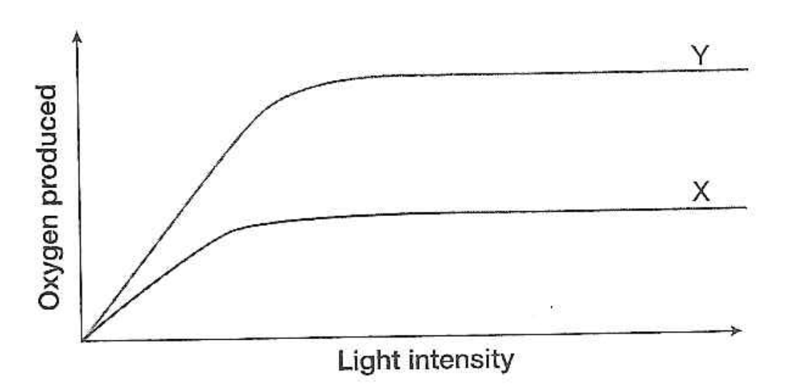

- What can you conclude from this graph? What happens to the rate of photosynthesis in X and Y as the light intensity increases? (1 mark)

- The rate of oxygen production increases to a certain extent and then it flattens out (1/2)
- Y has a higher rate of oxygen production than X (1/2)

- Explain how can plant growers use this information to increase the growth of crop?
(2 marks) ____________________________________________________________________________________________________________________________________________________________________________________________________________________________________________________________________________________________
- Generally, increasing the light intensity increases the rate of photosynthesis (1), until some other factor (a limiting factor e.g. carbon dioxide) becomes in short supply (1).

- Plants with C4 photosynthesis have a competitive edge over plants with C3 photosynthesis.

a) Explain this statement. (2 marks)
- C4 plants are more efficient than C3 plants due to their high rate of photosynthesis (more biomass) (1) and reduced rate of transpiration (1).

b) Using an example, state how plant growers can use this information to increase the growth of crop? (2 marks)
- Generate C4 rice in the lab (1) or use C4 plants instead (1)
- Explanation (1)

End of assessment

